>> Intelligent Systems – WG 1 <<

Sets, Graphs, Trees

State-Space Representations

Uninformed Search

Concepts to be known after WG1 :

- Basic concepts of Discrete Mathematics
  - Set theory (union, intersection, complement, disjointness, cardinality)
  - Graphs
  - Trees
- State-Space Representations
  - Initial state
  - Goal test
  - Successor function
- Uninformed Search
  - Terminology search trees
  - Breadth-first search
  - Depth-first search
  - Depth-first iterative deepening

Exercises 1: Naïve Set Theory
Exercise 1a: Given A = {1, 3, 8, 10} and B = {6, 9, 12} for a Universe U={1,3,6,8,9,10,12}. Which of the following statements is/are TRUE?

- B is the complement of A
- A B = ∅
- A and B are disjoint sets
- B ⊂A

Exercise 1b: There are 25 elements in a universal set. If |A| = 10, |B| = 10 and |A B| = 10, what is the cardinality A union B, formally |AB|?
- 0
- 10
- 15
- 20

Exercises 2: Graphs
Exercise 2a: List all undirected graphs that have {a,b,g} as their vertex/nodes set. How many directed graphs are there with vertices {a,b}?
Exercise 2b: The adjacency matrix of a graph G is the matrix A defined as follows: adjacency for any two vertices u and v,
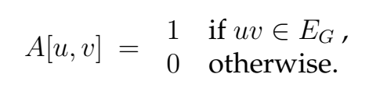
In other words, an adjacency matrix A for a graph G has a 1 if, and only if, there is an edge between nodes u and v, and a 0 otherwise. Write down the adjacency matrix for the graph:
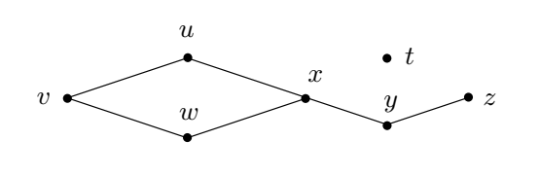

Exercises 3: Trees

Exercise 3: Annotate the following tree with labels: root and the leaves.
- What is the depths of the leaf-nodes, and thus the heights/depths of the tree?
- Which are the nodes with the same descendants as children?
- Which are the nodes which can be identified uniquely as the child of their parent?
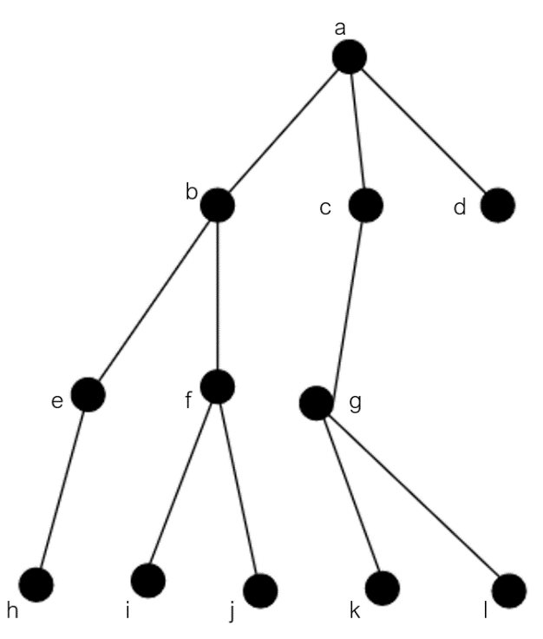

Exercises 4: Representation of State-Space Problems

Exercise 4: Give the initial state, goal test, successor function and cost function for the following problem. Choose a formulation that is precise enough to be implemented.
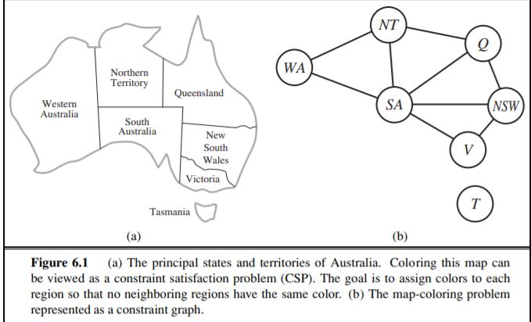
- You have to color the planar map of Australia using only four colors in such a way that no two adjacent regions have the same color.
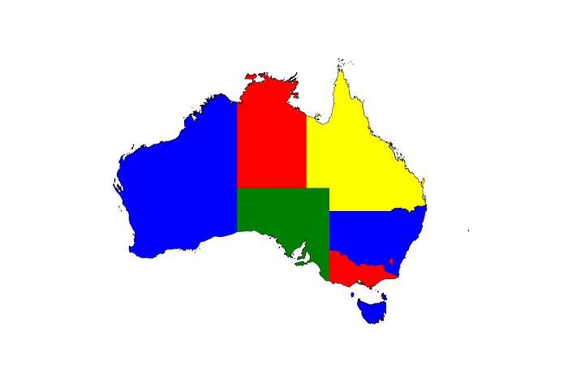

Exercises 5: Uninformed Search
Reminder: the Tree Search algorithm (pseudocode)

Please for the following
function TREE-SEARCH(problem,fringe) return a solution or failure
fringe ← INSERT(MAKE-NODE(INITIAL-STATE[problem]), fringe)
loop do
if EMPTY?(fringe) then return failure
node ← REMOVE-FIRST(fringe)
if GOAL-TEST[problem] applied to STATE[node] succeeds
then return SOLUTION(node)
fringe ← INSERT-ALL(EXPAND(node, problem), fringe)

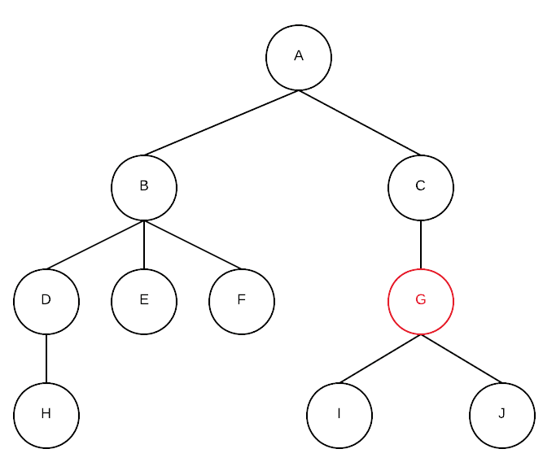
Exercise 5.1: Consider the following state-space diagram, where the lines are directed from top to the bottom, i.e. one can e.g. move from state A to B, but not back from B to A, etc.

- When you apply breadth-first search, which nodes will be visited before the goal node ‘G’ has been found?
- Which nodes when you apply depth-first search?
- Which nodes when you apply depth-first iterative deepening?
Exercise 5.2: Consider the following state-space, where the goal states are marked with thicker boundaries.
- When performing depth-first search, what is the order of the states that will be searched before you find the first goal state? Give the answer in letters.
- Do the same for breadth-first search.
- And for depth-first iterative deepening.
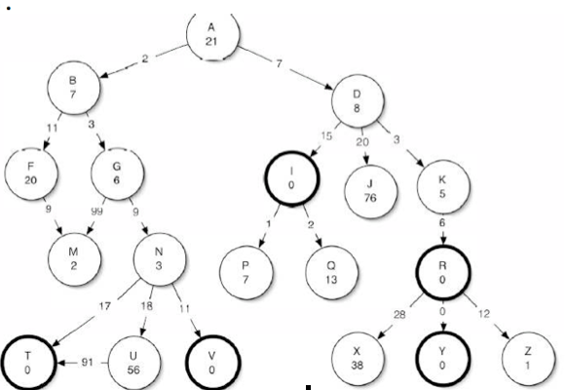

Exercise 5.3:
When do you advise to search data-driven (or ‘data-directed’ or ‘forward searching’) instead of goal-driven (or ‘goal-directed’ or ‘backward searching’)?
Exercise 5.4:
What are the advantages and disadvantages of breadth-first compared to depth-first searching algorithms? Discuss at least two different aspects.
Exercise 5.5:
Give an example of a search tree in which depth-first iterative deepening would be much more expensive (in terms of computing time) to use compared to depth-first search?

